|  |  |
| --- | --- |
| Ex No: 10 | **Entity RELATIONSHIP Diagram** |
| Date : 11/10/2021 |
| Video Link: |  |

**OBJECTIVE**

The objective of the experiment is to model Entity Relationship diagram for the --------------------- project.

**DESCRIPTION:**

An entity relationship diagram (ERD) shows the relationships of entity sets stored in a database. It is usually drawn in a graphical form as boxes (entities) that are connected by lines (relationships) which express the associations and dependencies between entities. An ER diagram illustrates the logical structure of databases. Also, ER diagrams are used to sketch out the design of a database.

**Components of ER diagram**

**Entity:** An entity is an object or concept about which you want to store information. An entity set is a collection of similar entities. These entities can have attributes that define its properties.

**Attribute:**  Attributes could be properties or traits of an entity A key attribute is the unique, distinguishing characteristic of the entity. An entity’s attribute is made unique or related with another entity by declaring attribute key.

**Entity Relationship**

A primary key is used to ensure data in the specific column is unique. It is a column cannot have NULL values. It is either an existing table column or a column that is specifically generated by the database according to a defined sequence.

A foreign key is a column or group of columns in a relational database table that provides a link between data in two tables. It is a column (or columns) that references a column (most often the primary key) of another table.

**Cardinality:** Cardinality specifies how many instances of an entity relate to one instance of another entity.

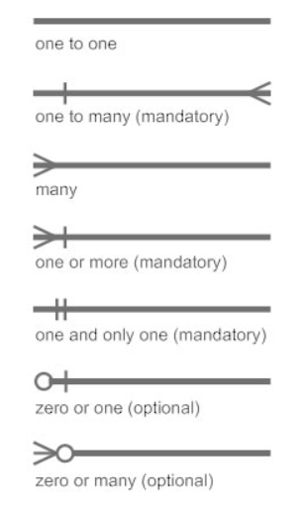

However, STARUML supports One-to-One Relationship, One-to-Many Relationship or Many-to-Many Relationship.

**ALGORITHM**

Step 1: Identify the cardinalities and its attributes to the system to be drawn.

Step 2: Identify the primary keys, foreign keys for the attributes.

Step 3: Determine how the cardinalities between the entities are formed

Step 4: Create the ER diagram based on the information from step 1 to 3 with the StarUML provided.

**OUTPUT:**

**PASTE ER DIAGRAM OF YOUR APPLICATION HERE**

**RESULT:**

The Entity Relationship diagram for ------------------ project was modelled successfully.